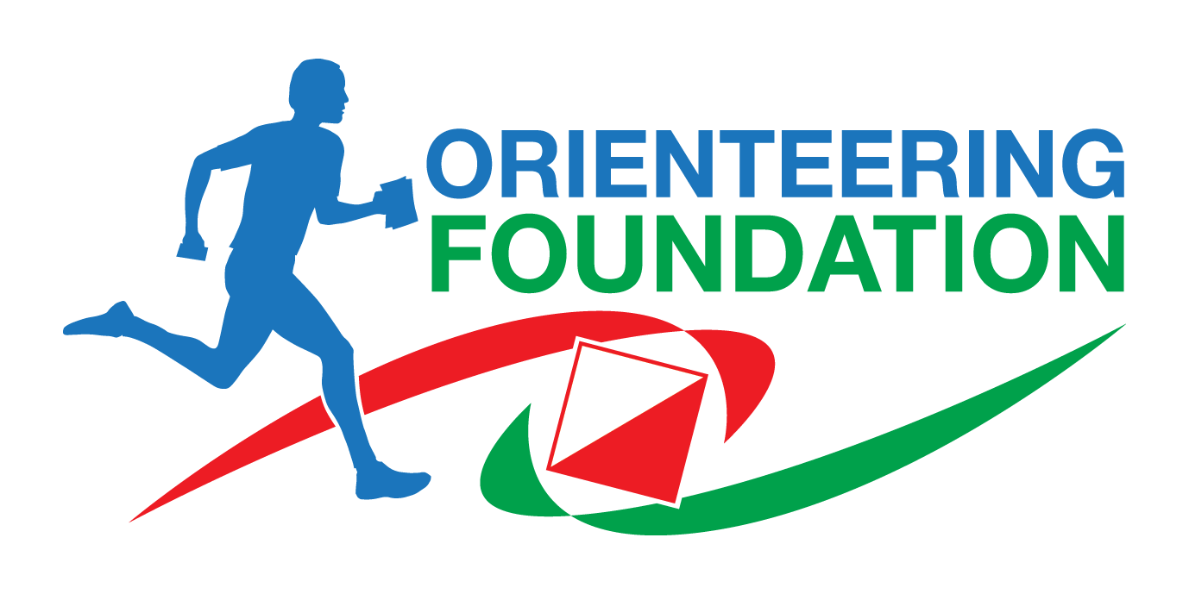
GRANT APPLICATION FORM
Details of project or activity

This form may be completed electronically (preferred). Please add additional lines / space / pages as required when answering the questions (there is no word limit).

Club / Association / Group / Individual the application is for:

Project or activity name (suitable for publicity purposes):

Location:
Start date:
End date:
Description of project or activity:

How it meets the Orienteering Foundation’s criteria (enhancement, hardship and / or innovation):

Impact of not receiving Orienteering Foundation funding (e.g. cancelled or reduced scope):

Measurable targets/outcomes for the project (e.g. number of coaching sessions or participants):

Total cost of project or activity:

Total Orienteering Foundation funding applied for (and which particular part of the project it would be used for, if appropriate):

Other funding sources (amount, from where, applied/received):

Is acceptance of award of funding conditional on anything (e.g. selection to a team / competition):

Submission deadline applied for
- 31st March
- 30th June
- 30th September
- 31st December
Applicants are encouraged to submit their applications as soon as they are ready and not wait for the deadline, as the Trustees could be looking at the applications and raising any points of clarification.
Contact Name:
Role within club / association / group (if applicable):
Contact address:
Contact email:
Contact phone (home / mobile / work):
EITHER payee for award cheque and address to send to:
OR account to transfer award funds to
Account holder name:
Sort code:
Account number:
Application forms MUST be accompanied by:
- A copy of the budget for the project, showing all sources of funding / income (and identifying the aspect for which the grant is being applied to, if applicable)
- Latest available club / association / group accounts (not required for individual applications)

Application forms should be sent in electronic form to our administrator Viv Macdonald admin@orienteeringfoundation.org.uk (preferred) or posting a copy to Viv Macdonald, Orienteering Foundation, c/o British Orienteering, Scholes Mill, Old Coach Road, Tansley, Derbyshire DE4 5FY. By accepting an award you agree to the following conditions:
- The Orienteering Foundation may publicly state the award has been made, and its amount.
- You will write a report within 60 days of completion of the activity or project, and provide photos if possible, for publication on the Orienteering Foundation website and other media.
- If you or your organisation has a website, blog, or similar, you must indicate on it you are supported by the Orienteering Foundation, with our logo, and a link to the Orienteering Foundation website, within 30 days of confirmation of the award, and keep it there for at least 6 months after the end of the activity or project.
- We would expect all grant recipients to abide by British Orienteering rules and policies
- All activities involving children and vulnerable adults must be undertaken in accordance with the latest British Orienteering O safe policy, which is currently well down this page from the British Orienteering resource library.
If the grant conditions are not met, or for any reason the project does not go ahead or does not complete, the Orienteering Foundation reserves the right to require repayment of the grant (in whole or part).

Signature of applicant ……………………………………………………………………… Date …………………………….
Guidance for grant applications
The Trustees of the Orienteering Foundation would like to ensure that the grants given to applicants fall into one or more of the following categories:
- Enhancement
- Hardship
- Innovation

Enhancement – Any application for a grant would need to demonstrate that, without the support, the activity would be less effective. The grant could for example:
- enhance the participants' experience of the sport; or
- give long term benefit to the orienteering community (either to a particular group of orienteers or geographically).

Hardship – The grant would be used to give bursaries in case of demonstrable hardship to enable something of benefit to orienteering to take place, for example:
- coaches wishing to improve their experience
- young orienteers wishing to develop their skills (eg technical skills, mapping)
- aspiring/talented orienteers wishing to widen their experience at international level.

Innovation – The grant would be given for promoting activities and events which demonstrate innovation that might not otherwise take place. For example
- activities for disabled people and/or people with learning disabilities
- activities for young people below 16 and/or 16 – 25 year olds in order to retain them in the sport
- a different or novel type of event or activity
- attracting people who are not usually involved in orienteering
- market research on increasing participation
- marketing the sport.

Please endeavour to submit your application before the project is committed or the event happens. However, if there is a good reason why that is not possible, you can still submit afterwards.

For applications for club development officer (CDO) funding:
- Based on our experience, applications typically need to be for a period of 2-3 years, given the lead in time to appoint suitable people and for them to become effective
- Payments made in instalments (for example yearly) would be dependent upon providing a progress report and assessment of whether the targets have been met or are still capable of being met before further payments will be made
- successful clubs must commit to sharing their material, so that we can spread good practice.

You can find more tips for writing a good application for any sort of project at: https://www.orienteeringfoundation.org.uk/writing-a-good-application

