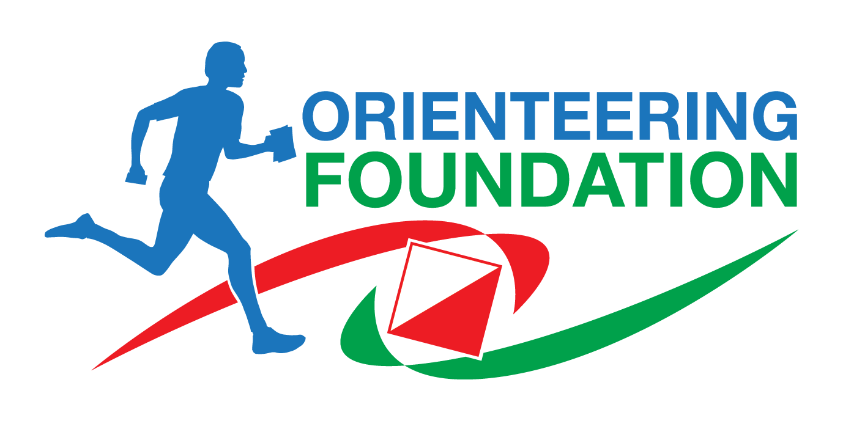

Orienteering Foundation Volunteer Effort Project
Group Member volunteer form

Thank you for your interest in being a member of the Volunteer Effort Project group: for details of the group's remit and what will be expected of group members, see a separate sheet.

When completed, please send this form to Andrew Evans, andrew.evans444@btinternet.com by 15th September 2023.

Name: ………………………………………………………… Club: ……………………….

Email address: …………………………………………………………………………………..

Phone (mobile): ………………………………………Phone (home) …………………………

What experience do you have of dealing with orienteering volunteers?

…......................................................................................................................................

…......................................................................................................................................

…......................................................................................................................................

Why do you wish to be a group member and what skills can you offer the group?

…......................................................................................................................................

…......................................................................................................................................

….....................................................................................................................................

We will contact you after 15th September 2023 about the composition of the group.

